Bryan Sugiarto

Assignment 4 [each question is worth 2 points: total 12 points]

Q1. Create the precedence graph for the schedule: w1(X), r1(X), w2(Y), r3(X), w1(Y), w1(X). Based on the graph, determine whether the schedule is conflict-serializable.

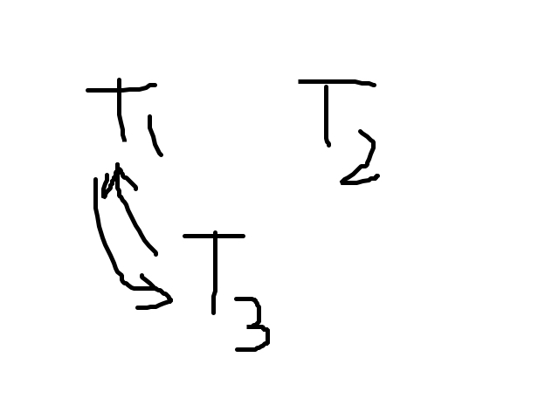

**It is not conflict-serializable.**

Q2. What is the difference between serializable and conflict-serializable schedule. Why are they not the same thing?

**Conflict serializable is a subset of serializable, so just because a schedule is conflict serializable does not mean it is serializable. If a schedule is serializable it is indeed conflict serializable.**

Q3. Consider the following schedule:

r1(A);r2(B);???;w1(C);w2(A);

What value for ??? will make the schedule not serializable. Give one such possible value.

**w1(B)**

Q4. Consider the transactions *T*1 and *T*2.

*T*1 : *r*1(*A*); *w*1(*A*); *r*1(*B*); *w*1(*B*);

*T*2 : *r*2(*B*); *w*2(*B*); *r*2(*A*); *w*2(*A*);

Give an example of a conflict-serializable schedule and non conflict-serializable schedule for the eight actions.

**non conflict-serializable = *r*1(*A*); *w*1(*A*); *r*1(*B*); *w*1(*B*); *r*2(*B*); *w*2(*B*); *r*2(*A*); *w*2(*A*).**

**conflict serializable = *r*1(*A*); *w*2(*A*); *r*2(*A*); *w*1(*A*); *r*1(*B*); *r*2(*B*); *w*2(*B*); *w*1(*B*);**

Q5. Show how a scheduler that follows the two-phase-locking protocol will work if the following operations come in this order: *r*1(*A*); *w*1(B); *r*2(B); *w*2(C); *r*3(C); *w*3(A);

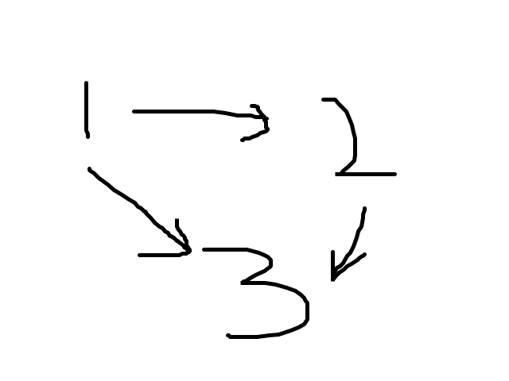

**Starting from 1 the two phase- locking protocol works. There are no cycles so the two-phase locking protocol will work.**

Q6. Are the following schedules conflict-serializable?

a) *r*1(*A*); *w*1(B); *r*2(B); *w*2(C); *r*3(C); *w*3(A);

**yes**

b) *w*3(*A*); *r*1(A); *w*1(B); *r*2(B); *w*2(C); *r*3(C);

**no**